|  |  |
| --- | --- |
| Course: Automated Testing Basics in Java (CEE) Topic: Maven Build Tool | Alina Ovcharenko  20.04.2023 |

1. Install Maven and make sure it works.

Maven has been successfully installed on the device.

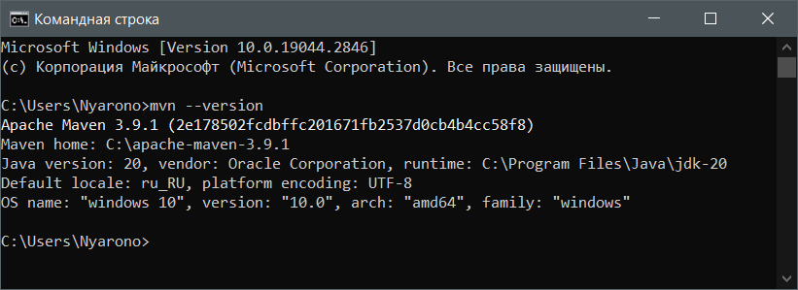

2. Download the test project from here https://github.com/vitalliuss/helloci/tree/master/Java and collect it with Maven using the test target.

Further, as it was said in the instructions, I downloaded the test project from the link and collected it with Maven using the test target.

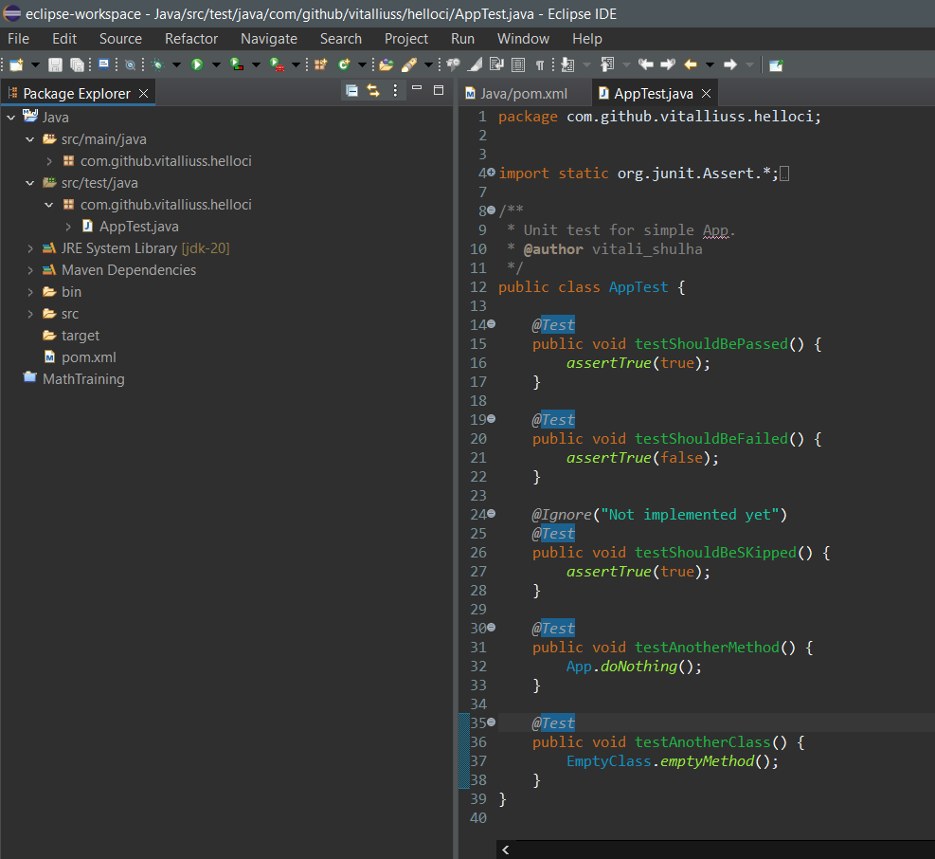

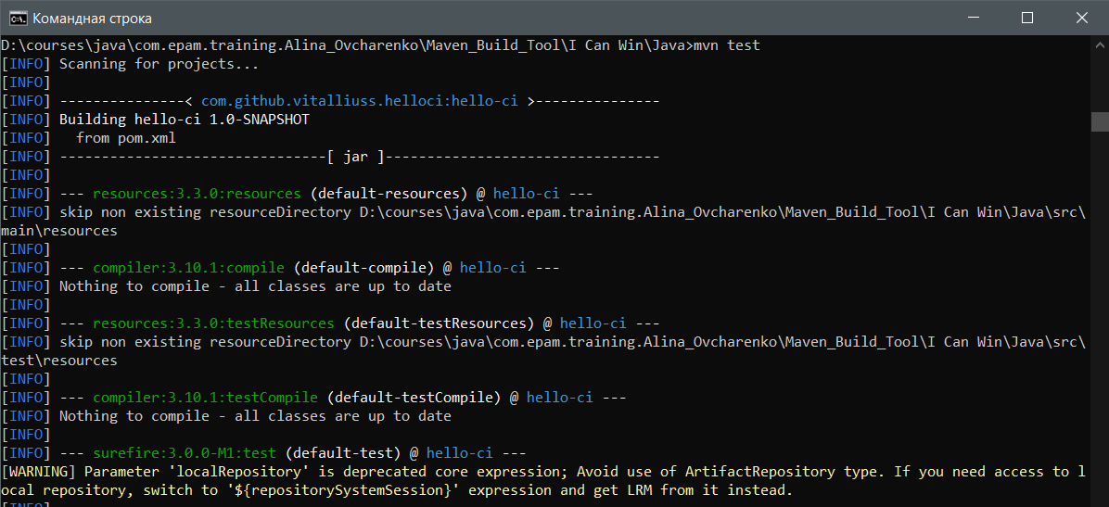

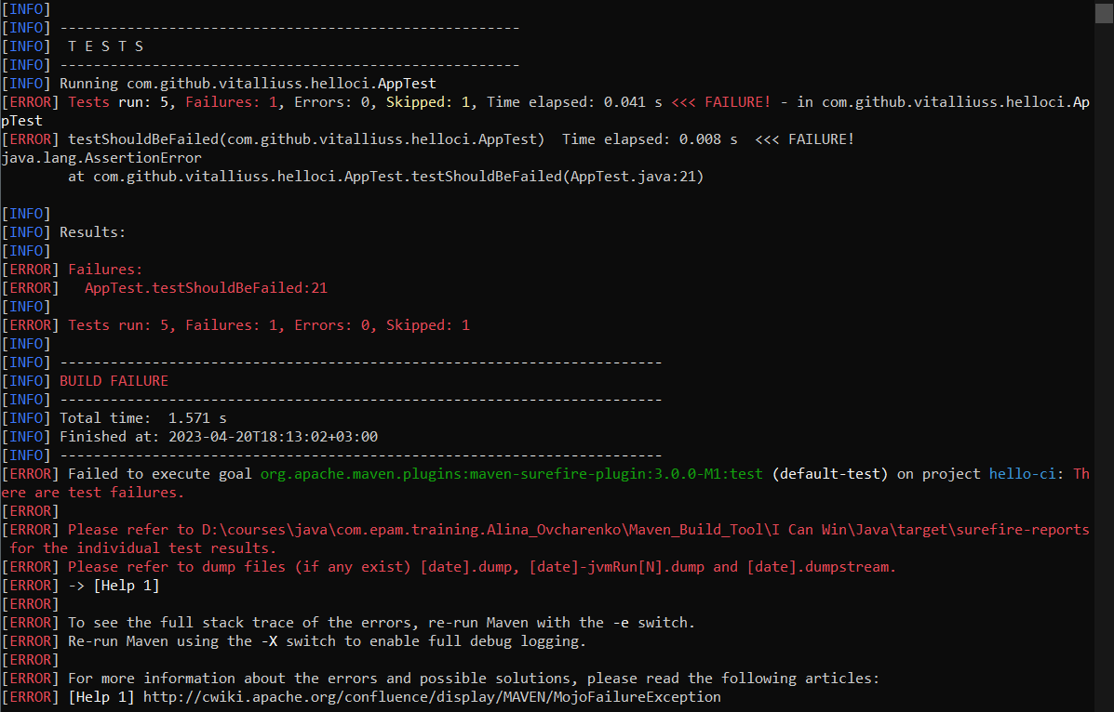

Everything matches, including the test that must be failed.

3. Find the junit libraries in the folder c: \ Users \ User_Name \ .m2 \ repository \  and look at the date when the files were created.

The file creation date matches the date of the test run.

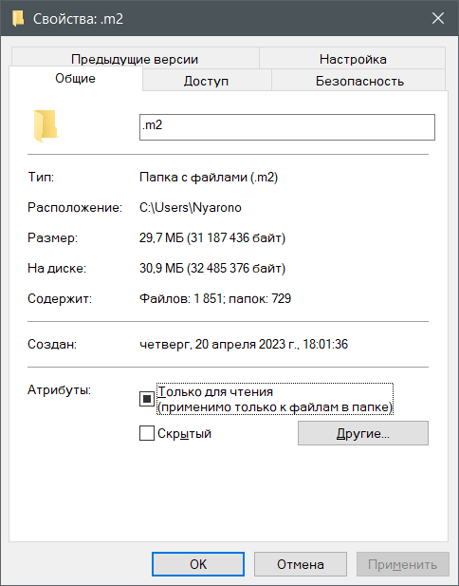

4. Change the junit version in the file pom.xml from 4.12 to 4.11 and collect the project again. Make sure the new version of the library has been added to .m2 / repository.

In the test project, the junit version is 4.13.2. I will change the version as requested.

